WEEK 2

Mandatory Hands-On

**Test Driven Development**

**EX:1 Mocking and Stubbing**

**Dependency:**

<dependencies>

<dependency>

<groupId>org.junit.jupiter</groupId>

<artifactId>junit-jupiter</artifactId>

<version>5.10.0</version>

<scope>test</scope>

</dependency>

<dependency>

<groupId>org.mockito</groupId>

<artifactId>mockito-core</artifactId>

<version>5.11.0</version>

<scope>test</scope>

</dependency>

</dependencies>

**ExternalApi.java**

package org.example;

public interface ExternalApi {

String getData();

}

**MyService.java**

package org.example;

public class MyService {

private final ExternalApi externalApi;

public MyService(ExternalApi externalApi) {

this.externalApi = externalApi;

}

public String fetchData() {

return externalApi.getData(); // No argument needed now

}

}

**MyServiceTest.java**

package org.example;

import org.junit.jupiter.api.Test;

import static org.junit.jupiter.api.Assertions.assertEquals;

import static org.mockito.Mockito.*;

public class MyServiceTest {

@Test

public void testExternalApi() {

ExternalApi mockApi = mock(ExternalApi.class);

when(mockApi.getData()).thenReturn("Mock Data");

MyService service = new MyService(mockApi);

String result = service.fetchData();

assertEquals("Mock Data", result);

}

}

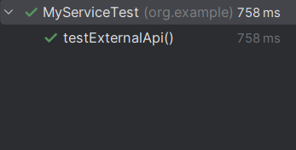**Output:**